**GREENWOOD COLLEGE**

**Mathematics Methods Units 3 & 4**

**Test 3 Integration 2019**

Name Mark /19

**All electronic devices must be switched off and in bags.**

**Access to Formulae Sheet allowed. No notes.**

**No calculators allowed in this section. Time limit 20 minutes.**

1. [ 1, 1 = 2 marks]

For a positive function $a(x)$, $\int_{2}^{5}{a\left(x\right)dx}$ = 10 and $\int_{5}^{9}{a\left(x\right)dx}$ = 12.

Determine:

a) b)

2. [ 4 marks]

Use the Fundamental Theorem of Calculus to find the area between the $x$-axis and $y=\sqrt{x}$ from = 1 to = 9

3. [ 2,2,2 = 6 marks]

Integrate with respect to :

a) b)

c)

4. [ 3 marks]

Determine $\frac{d}{dx}(x\cos{x)}$ and hence find .

5. [ 2,2 = 4 marks]

Determine $\frac{dy}{dx}$ for the following:

a) $y= \int_{1}^{x}{\frac{1}{\sqrt{1+t^{2}}}}dt$ b) $y= \int_{a}^{x}{\frac{d}{dx}(4t^{3})}dt$

END OF SECTION

**GREENWOOD COLLEGE**

**Mathematics Methods Units 3 & 4**

**Test 3 Integration 2019**

Name Mark /37

**All electronic devices must be switched off and in bags.**

**Access to Formulae Sheet and one sheet of A4 notes allowed. Use of approved calculators is assumed in this section.**

**Time limit 35 minutes.**

6. [5 marks]

The shaded region on the graph below is enclosed by the curves  and .

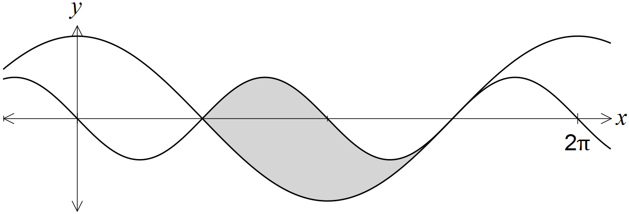

Show that the area of the region is 4 square units.

**7.** **[ 2,2,6,2 = 12 marks]**

Callum is happily paddling his kayak on the Greenwood College Outdoor Education camp until his craft hits a rock. Water begins to leak in at the rate of $R_{1}\left(t\right)=5-5e^{-0.2t}$

litres per minute, where $t$ is the time in minutes.

Callum starts to bail the water out of his kayak , removing at a rate of $R_{2}\left(t\right)=6-6e^{-0.1t }$ litres per minute.

**a)** After 2 minutes, at what rate is the water:

**i)** leaking into the kayak **ii)** being bailed from the kayak

**b)** Is the amount of water in the kayak increasing or decreasing after 2 minutes ?

Explain your answer.

**c)** Evaluate the following integrals, and interpret their meaning:

**i) $\int_{0}^{3}{R_{1}\left(t\right)dt}$**

**ii) $\int_{2}^{5}{R_{2}\left(t\right)dt}$**

**iii) $\int_{0}^{8}{[R_{1}\left(t\right)-R_{2}\left(t\right)]dt}$**

**d)** How much water is in the kayak after 10 minutes ?

8. [ 2,5,1 = 8 marks]

The speed, in metres per second, of a car approaching a stop sign is shown in the graph below and can be modelled by the equation $v\left(t\right)=6\left(1+\cos\left(0.25t\right)+\sin^{2}\left(0.25t\right)\right)$, where $t$ represents the time in seconds.

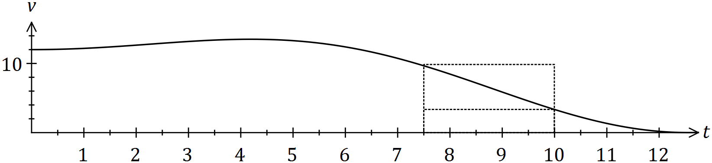

The area under the curve for any time interval represents the distance travelled by the car.

(a) Complete the table below, rounding to two decimal places.

|  |  |  |  |  |  |
| --- | --- | --- | --- | --- | --- |
| $$t$$ | $$0$$ | $$2.5$$ | $$5$$ | $$7.5$$ | $$10$$ |
| $$v(t)$$ |  |  |  |  | $$3.34$$ |

(b) Complete the following table and hence estimate the distance travelled by the car during the first ten seconds by calculating the mean of the sums of the inscribed areas and the circumscribed areas, using four rectangles of width 2.5 seconds.

*(The rectangles for the 7.5 to 10 second interval are shown on the graph.)*

|  |  |  |  |  |
| --- | --- | --- | --- | --- |
| Interval | $$0-2.5$$ | $$2.5-5$$ | $$5-7.5$$ | $$7.5-10$$ |
| Inscribed area |  |  |  | $$8.35$$ |
| Circumscribed area |  |  |  | $$24.15$$ |

(c) Suggest one change to the above procedure to improve the accuracy of the estimate.

9. [5 marks]

The area bounded by the curve  and the lines ,  and  is exactly  square units. Determine the value of the constant k, given that .

**10. [2,2,3 = 7 marks]**

A particle is initially at the origin and moving to the right at 5 cms-1. It accelerates with time according to the rule cms-2.

**a)** Determine the velocity function of the particle.

**b)** For the first 6 seconds of motion, determine the displacement of the particle.

**c)** For the first 6 seconds of motion, determine the total distance travelled.

END OF PAPER